Information on the Galloway-farms

World Galloway Conference 2014

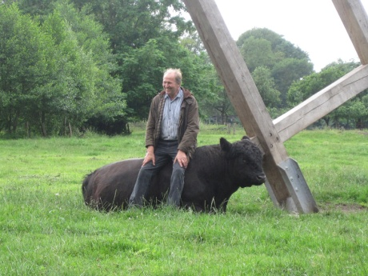

Thursday, Sept.04.2013

Last name: Göttke-Krogmann

First name: Jürgen

Adress: Diepholzer Str.21, Kroge, 49393 Lohne

Phone / Mobile: 0049 4442-4433 / 0049 152 53 457 257

Email: j.goettke-krogmann@t-online.de

Herdname: Galloways von Kroge

Livestock: about 35 Galloways, including offspring

Color: black

Land: about 20 ha, 4 ha are located near a moor

Machinery and

Equipment: 1 tractor (60 PS), different equipment used for pasture care

and hay harvest, manure spreader

Buildings: open stable with a paved courtyard to feed the cattle in

Winter time

Labor: 0,5

Specials and history :

Jürgen Göttke-Krogmann worked over 30 years as a landscaper in the local administration for conservation management. He was responsible for moor protection. In the district of Vechta, he gained a lot of experience in practical landscape management of peat grassland. In 1985 he started with pedigree cows and non pedigree cows. The pastures are used extensive and near to his farm. Galloway bulls for his breeding herd are purchased regularly. The genetics of the cows based on two Scottish breeding lines from J.R. Wallace “Primrose of Over Barskeoch” and J.Hutton & Sons “Wellhill Fluffy 28th”.

Since 1990 Göttke-Krogmann sells his Galloway meat himself.

In 2009 Göttke-Krogmann build a station for schools to teach young people something about the history and the care of the regional landscape. Since then, the farmer led not only pupils but also a lot of students and tourists across his farm and explained extensive cattle farming and the particular history of the typical “Plaggenesch” soil. Meanwhile, a barn had been converted to an information center. Between travelers and tourists who want to learn something about the development of landscape in northern Germany is the farm of Göttke-Krogmann an insider tip.

Friday, Sept.05.2013

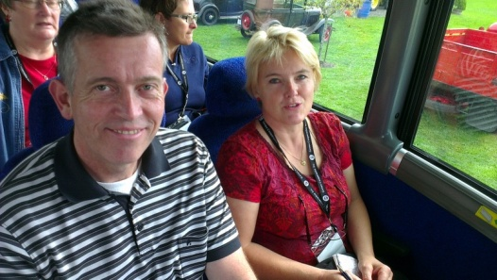

Last name: von Hollen

First name: Karl-Ludwig

Adress: 24321 Giekau, Am Buchholz 8

Phone: 0049-4381-414216, 00491714290701

Email: [hollenkalu@t-online.de](mailto:hollenkalu@t-online.de)

Homepage: [www.schoenweider-galloways.de](http://www.schoenweider-galloways.de)

Herdname: Schönweider Galloways

Livestock: ca. 75 Galloways incl. offspring

26 horses

Color: black, white

agricultural land: 7 ha pasture

45 ha arable land

1 ha farm area

Machinery : 1 Valtra Four-wheel tractor with frontloader, 80 PS, 1 wheel

loader, 54 PS, 1 ATV, 1 disc-mower, windrower, tedder,

mulching machine, round bale trailer, life stock trailer

Building: 88 covered feeding places for cattle, two machine halls,

stable for 26 boarding horses, additional 14 boxes for guests,

riding arena, riding court, round pen

labor: 1,5

Specials and history:

Karl-Ludwig von Hollen breeds since 1987 black Galloways on his farm in Gottesgabe in the south of Kiel, which is the capitol of Schleswig-Holstein. The cattle are kept outside the whole year. An open barn gives protection against wind and cold and the possibility of a controlled feeding in wintertime with silage and straw. The cattle can be held in the barn for the veterinarian treatment.

Since 1996 the breeder uses proven genetics from Canada and Scotland. His breeding goals are well muscled long bodies which guarantee an optimally productivity and correct legs and feet. The females should have a long productive life and calve easily with no assistance. The cows have to take care of the newborn vital and healthy calves. The oldest cow in the herd is 16 years old and hopefully will have her 14th calve in spring.

In the TOP list 2013 concerning 27 best cows of the extensive breeds in Germany you will find five cows from Karl Ludwig von Hollen. His Galloways are on the first, third and fifth place. One has 14 offsprings, the others 13 and 10. In the list for the bulls two of his bulls are on the 2nd and 3rd place.

The offspring was not only sold in Germany but also in Austria, Russia and Scotland. Hollen sells the meat direct to customers in region.

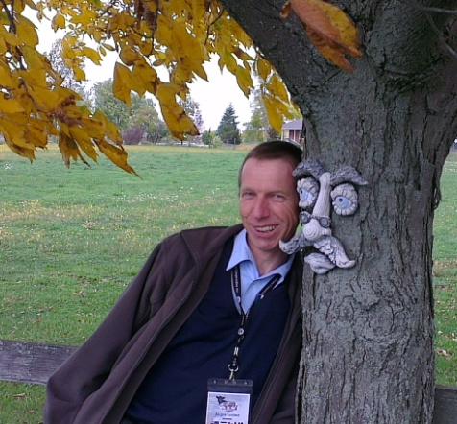Last Name: Greiner

First Name: Jürgen

Adress: 24576 Hagen, Ginsterweg 1

Phone: 04192-7182

Email: [j.greiner@holsten-galloways.de](mailto:j.greiner@holsten-galloways.de)

Homepage: www.holsten-galloways.de

Herdname: Holsten Galloways

Livestock: rd. 150 Pedigree cows

Colour: Black & Dun

Agricultural land: 90 ha owned, 35 ha rented land

Machinery: Panels, cattle crate, round bale feeders, cribs,

Mineralfeeders, automatic drinking bowls-

Electric fence

Buildings: barn for machinery and feed

Labor: 2.0 AK

Specials:

All Galloways are kept outside the whole year. Some bushes are used for protection against strong winds and sun. During the whole year we are feeding grass and straw and also dry sugar beet pulp and rape expeller. Minerals which are rich in magnesium is also given the whole year. All two year old bulls are sold to a slaughterhouse. Heifers which are nervous, too masculine or more than 15% under the average wheight are also slaughtered. All other heifers which weigh more than 380 kg and which are older than 15 month are kept for breeding. Since 2002 we exported more than 200 head to Netherlands, Switzerland, Denmark, Tschecheslowakia, Austria, Romania, Bulgaria, Russia and Scotland.

Saturday, Sept.06.2013

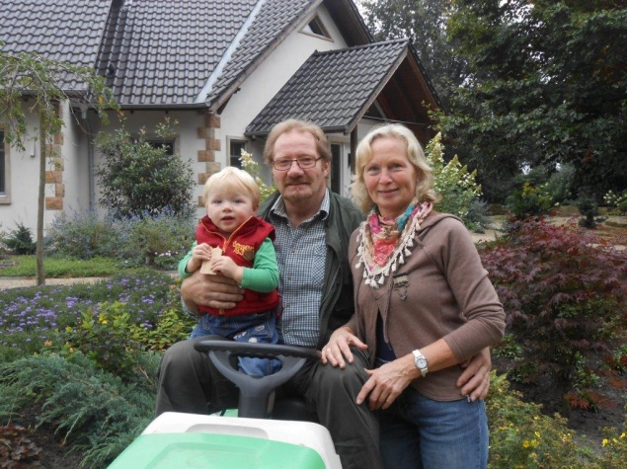Last name: Gerling

First name: Karl-Heinz

Adress: Feldburgweg 16

Phone: 0049 5459-8220

Email: [Galloway-gerling@t-online.de](mailto:Galloway-gerling@t-online.de)

Homepage: [www.galloway-gerling.de](http://www.galloway-gerling.de)

Magda and Karl-Heinz Gerling with her grandchild Bastian

Herdname: Galloway vom Felde

Livestock: 45 Galloways, including offspring

Colour: black, red, dun, white, rigget, red brindle

Land: about 25 ha pasture

Machinery and

Equipment: 1 tractor 105 Ps, 1 tractor 60 PS, mower, tedder, windrower,

various equipment for pasture care

Buildings: residential building and various barns

Labor: 1,2

Specials and history:

Karl-Heinz Gerling took over the farm from his parents. In 1989 he decided to farm in future as a sideline and to create other operation branches. He stopped bull fattening and piglet production. “This decision wasn´t avoidable because a growing - which should have been necessary to ensure the existence of the farm in future - was not possible,” explains Gerling. The arable land around the farm was sown and used in the future as meadows and pastures for his Galloway. The remaining farmland was leased. Today Karl-Heinz Gerling works in the army.

Some years he and his wife tried to market the Galloway meat itself. Both quickly realized that this business wasn´t for them and so they concentrated on breeding livestock marketing. Today, they successfully sell animals not only in Germany but also in Denmark, Hungary, Austria, Switzerland, France and Luxembourg.

"Even as a child I was interested in the colors of breeding pigeons, rabbits and ducks," Gerling admits. Therefore, he remains true to his passion for the Galloways. In his herd you find rare color shots as dark-rigget, rigget-red, dark-red-white or brindle.

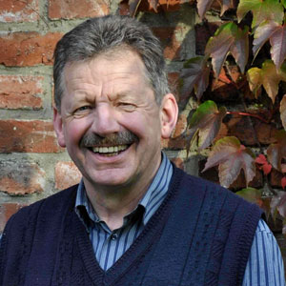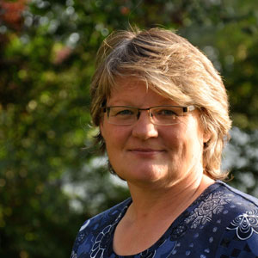Last Name: Becker

First Names: Ursel und Georg

Adress: Grambergweg 3, 49191 Belm-Haltern

Phone.: 05406-2576

Email: gallowayhof-becker@osnanet.de

Herdname: Gallowayhof-Becker

Homepage: www.gallowayhof-becker.de

Livestock: 90 head of Galloways

Colour: Black - plus acquisitions for slaughter

Agriculture land: ca. 46 ha, including 33 ha nature land

Machinery

2 tractors (35 und 70 PS), disc mower, tedder

Buildings: 2 barns

Labor: 0,5 for the farm and cattle and 1.5 for the farm shop

Specials:

The Beckers live on the farm from Ursels parents. Years ago there was an empty meadow beside the farm and we were looking for the right cattle to graze, so we found the galloways and started in 1985 with two heifers. When we started we owned no farmland and no buildings but we had the dream to be fulltime farmers with galloways. In the early 90th we started with direct marketing and sold up to eight Galloways per year. In 1997 somebody offered us a place at the weekly market in Osnabrück. That was our chance to build up our direct marketing. Today we offer 80 different Galloway products at three weekly markets. Every year we slaughter ca. 100 galloways , our own and some we buy. The dream comes true we build up a fulltime Galloway farm.

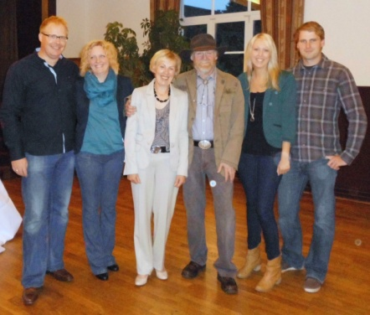Last name: Behrens

First name: Maria und Bernhard

Adress: Ueffelner Str. 119, 49594 Alfhausen

Guido and Annemarie Eyemann, Maria and Bernhard Behrens, Friederike and Bernd Behrens

Phone/ Fax: 0049 5464-1871 / 0049 5464-1773

Email: email: [Behrens.Bernhard@web.de](mailto:Behrens.Bernhard@web.de)

Herdname: Gallowaybetrieb Behrens

livestock: about 41 Galloways including offspring

colour: white

Land: 54 ha, 40 ha of it are located in a nature reserve

Machinery

and equipment: 1 tractor 86 PS, 1 wheel loader, mower, windrower, tedder,

mulching machine, round bale trailer

Buildings: 3 Coverall halls

Labour : 1 Ak

Specials and history:

Our adventure „Galloway“ began on the first October in 1988 with two white heifers which have Scottish pedigrees. Then we started the search for a suitable white bull. We found him on the island Helgoland. In the years 1990 and 1991 we bought together with the Dieter Bojes Galloways in Canada. We hold two white heifers for our own breeding. That was the beginning of a deep friendship with the Canadian breeders Lee, John, Betty and George McIllwraith, Dawn and George von Kampen. We visited this families several times.

Our traveling during the last years led us back to the motherland of the Galloways – Scotland. Over the years our livestock grows to more than 70 animals. In the moment “only” 41 Galloways run on our pastures. We are an organic farm which has a European certification.

After the wonderful World Galloway Conference in Canada we are looking forward to welcome you all in 2014 in Germany.

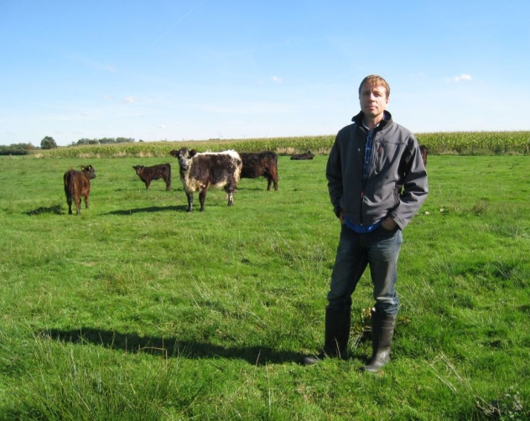Last name: Kinkhorst

First name: Bernd

Adress: Roggenberg 5

Phone: 0049 5442 1803

Email: [BerndKinkhorst@web.de](mailto:BerndKinkhorst@web.de)

Herdname: Galloways vom Vogelsang

Livestock: 90 Galloways in average, including offspring

Colour: black, white, rigget

Land: 60 ha pasture, 30 ha of it are located in a nature reserve

1 ha forest

Machinery

And equipment: 3 tractor, 30 – 75 PS, mower, windrower, tedder, hay press, mulching

machine, round bale trailer, life stock trailer

Buildings: 1 barn

Labor: 1,5

Specials and history:

Fritz Kinkhorst senior and Bernd Kinkhorst junior started with their families the breeding of black Galloways when the last Holstein Frisian left the stable in 1989. The breeders keep their cattle during the whole year outside on the pasture. The animals find protection against wind, sun and cold in the stables which they can enter or leave.

Since 1997 the farm is organic managed with an European certification. Breeding goal is to produce of not too little but long Galloways within a German type. Scottish, Canadian and Australian genetics are used since 1998. Kinkhorst bought semen and imported Galloways to improve the own breed.

Meanwhile Kinkhorst sells his offspring not only in Germany but in Lithuania, Latvia, Russia, Austria.

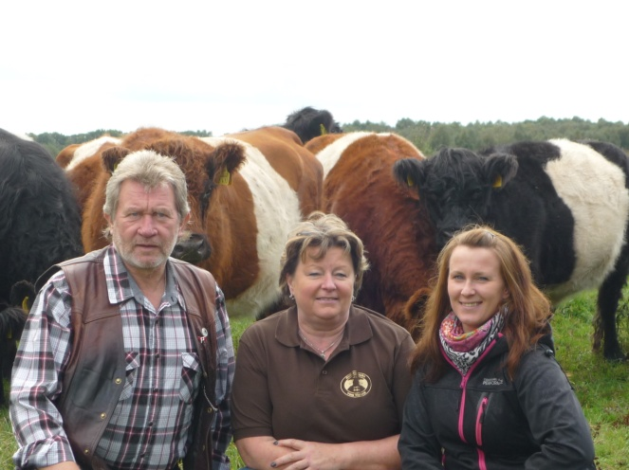Last name: Bojes

First name: Dieter and Annette

Adress: Rechtern 5, 49406 Barnstorf

Phone / Mobil: 0049 5442-8320 / 0049 171-5342189

Email: [dieter.bojes@t-online.de](mailto:dieter.bojes@t-online.de) Dieter, Annette und Sabrina Bojes

Homepage: [www.galloways-bojes.de](http://www.galloways-bojes.de)

Herdname: Galloways vom Walsen

Livestock: about 60 Galloways including offspring

Colour: black belted and red belted

Land: about 30 ha, 20 of them are located in the moor, a nature reserve

Machinery and

Equipment: 3 tractors (24-50 PS), mower, windrower, tedder

Buildings: 1 barn

Labor: 1,5

Specials and history:

In 1987 Annette and Dieter Bojes started to breed black Galloways. A few years later in 1991 the breeding concentrates on red Galloways. In 2001 Bojes and the breeder Jörn Hoppe build up a red-belted population.

The family runs their farm based on the European Organic Certification. Two third of the land is located in moor and a nature reserve. Special requirements as low stocking density and grazing only from the 15th April to the 15th November have to obey.

breeding animals are sold very successfully to organic farms. Also the farmer sells his meat to organic shops in the region. Best marketing for the Galloway meat is the „Bratwurst“-pavilion. With this booth Bojes goes to various feasts as there is the Barnstorfer Frühlingserwachen, Country Festival, Bauernmarkt in Heiligenloh and a lot more events.

The family breeds also very successful quarter-horses. Their daughter Sabrina is an enthusiastic show rider.

Sunday, Sept.07.2013

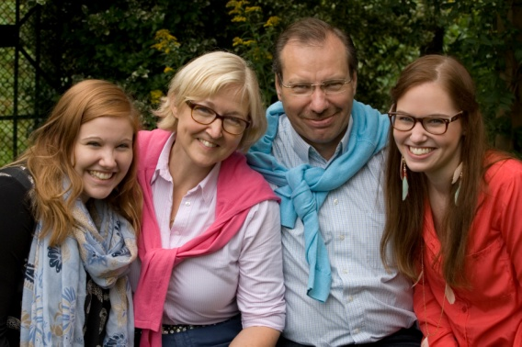Last name: Haase

First name: Carsten, Annette and their kids

Stephanie and Kristin

Adress: Matthiasstraße 3, 49 413 Dinklage

Stephanie, Annette, Carsten und Kristin Haase

Phone: 0049 4443/2786

Email: [Familie.Haase62@gmx.de](mailto:Familie.Haase62@gmx.de)

Homepage: [www.gallowayzucht-kronenhof.de](http://www.gallowayzucht-kronenhof.de)

Herdname: Gallowayzucht Kronenhof

Livestock: 54

Color: black and dun

Land: 30 ha

Specials and history:

The family breeds since 1989 with a lot of enthusiastic and pleasure dun and black galloways. It is important for us to deal respectfully with the nature and its creatures.

The most of our pastures are located in nature reserves and require a special environmentally friendly farming. Therefore we maintain and preserve the ponds, islands and many different biotopes.

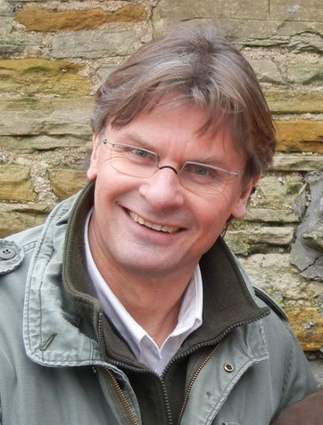Last name: Mallunat

First name: Axel

Adress: 49356 Diepholz, Lindloge 34

Phone: 0049 170 8351889

E-Mail: [mallunat-diepholz@etl.de](mailto:mallunat-diepholz@etl.de)

Homepage: [www.galloway-mallunat.de](http://www.galloway-mallunat.de/)

Herdname: Galloways vom Sonnenhof

Livestock: about 70 Galloways including offspring

Color: black, white, dun

land: 60 ha pasture

1 ha farm area

machinery

and equipment: tractor (Fendt) with frontloader, mulching machine,

manure spreader,

buildings: multi purpose Hall with 450 m²

with boxes for calving and feeding places

Labor: 1

Specials and history:

Since 1978 Axel Mallunat persued landscape conservation with sheep in Diepholzer Moor. In 1989 he decided to work with Galloways. That was the beginning of his Galloway breeding.

The soil in the Diepholzer Moor is light and the pasture affords animals which are able to use the forage optimal. During many years Mallunat selected his Galloways according to easy calving, easy to feed and a good motherly character. The breeder used Canadian and half Canadian genetics to increase the quality of his own breed.

In the beginning he used the bull Penninghame Waverley, followed by Westforrest Tippet (son of the National Champion of Germany Westforrest Tiger and Champion of the county Schleswig-Holstein in 2000). The bull Quilin vom Vogelsang (son of Sandrift Quasar) was National Champion of Germany in 2002.

Currently bulls Kosmo vom Vogelsang (Father is Blackcraig Kazan), Highland Laddie (Junior-Champion Castle Douglas; 2011), Karlos vom Sonnenhof (son of Holsten Karl; Champion of Schleswig-Holstein in 2012) and Entero vom Sonnenhof (grandchild of Westforrest Tippet) are in use for his black Galloways.

In 2002 the breeder bought a little herd of White Galloways. They form the basis of a successful breeding. In 2008 the white bull Earl of Moorehouse was honored as best white bull on the National Show of Germany and Reserve Champion over all bulls. Beside the black and white Galloways Mallunat developed a little herd of dun cattle. In best conditions is Ron - son of Robbin (breeded from a Silver Sun Komet cow).

The farm „Sonnenhof“ is known for its rare genetics. Not least, this is the reason for a lot of buyers outside Germany (Luxembourg, Lithuania, Rumania and Russia). What isn´t sold on four legs, will be slaughtered and sold as organic produced meat in direct marketing.

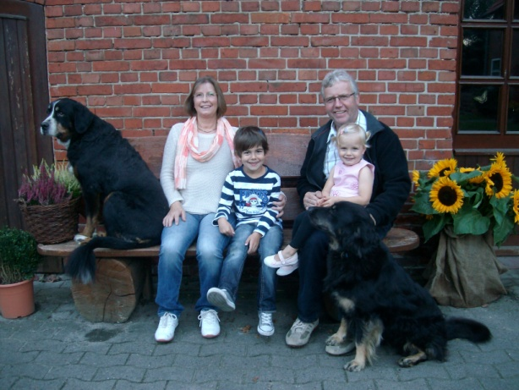Last name: Wiegmann

First name: Marion and Friedrich

Adress: 27232 Sulingen, Stehlen Nr. 2

Phone: 0049 4271 - 2810

Email: [friedrich.wiegmann@ewetel.net](mailto:friedrich.wiegmann@ewetel.net)

Marion und Friedrich Wiegmann, with her grandchilds Mika and Neele,

Herdname: Galloways aus dem Suletal

Livestock: about 80 Galloways including offspring

Colour: black

Land: 50 ha pasture

2,5 ha forest

4,5 ha moor

Machinery and

Equipment: 1 tractor (100 PS), 1 truck (Schabmöller), mower, hay press,

windrower, tedder, life stock trailer

Buildings: several barns and sheds on the farm

Labor: 2

Specials and history:

In 1989 the family Wiegmann decided to start with a new business sold their dairy cows and began to breed Galloways on their farm in Stehlen. Since that time the Wiegmanns are member of the Masterrind in Verden. Over the years they breed very consequently. Every year they use two or three bulls with different genetics in their herd. They are very proud of all in all six national champions since they start breeding.

The Galloways graze near by the farm the whole year. In the wintertime they feed hay and silage. The cattle used to have barley straw the whole year.

The cattle they don´t need for the breeding were slaughtered and self marketed. The family value calm and very tame animals.

At present Wiegmann produces piglets and use a pietrain boar. That will stop in 2013.

Marion and Friedrich Wiegmann have two daughters named Stephanie and Janin. The grandchildren, Mika and Neele, are the pride of them. Mika is five years old, loves to visit every Galloway-show and wants to become a young breeder.